Gazzetta Medica Italiana - Archivio per le Scienze Mediche 2021 September;180(9)
ORIGINAL ARTICLE
Gazzetta Medica Italiana - Archivio per le Scienze Mediche 2021 September;180(9):399-403
A new hypothesis to explain the mechanism that may be involved in the genesis of sleep bruxism
Antonio FERRANTE *

A new hypothesis to explain the mechanism that may be involved in the genesis of sleep bruxism (SB)
Dott. Antonio Ferrante
Docente Master ”Posturologia clinica” Univ. Pisa, Napoli
Autore di contatto: dott. Antonio Ferrante I trav. Luigi Angrisani, 23 84014 Nocera Inferiore (Sa) Italia e-mail dott.antonioferrante@gmail.com
Abstract
Objective: The present study aims at constructing a new hypothesis on bruxism’s potential neurological etiology. Bruxism is not regarded a parafunction or stress reaction but a non-physiological mechanism deployed by patients suffering from incorrect swallow and functional disorders of the trigeminal stimulation in order to support the memorizing of information during sleep and the attention span during the day. Methods: The study was conducted on 80 patients of both genders aged 20—34 years. All were suffering from impaired swallowing. The patients were randomized and clustered in two groups of each 40 persons. The first group’s patients (Group A) underwent myofunctional therapy according to Garliner (modified by Ferrante) for 3 months. Patients clustered in the second group were further divided into two groups of each 20 people. Twenty individuals (Group B1) did not receive any treatment and were simply monitored for bruxism; the remaining 20 patients (Group B2) used “Bite Strips” to reduce parafunctional activities. Inclusion criteria: Patients with night bruxism. Exclusion criteria: Patients with congenital or acquired craniofacial abnormalities, genetic syndromes, neurologic disorders, and psychiatric disorders. Patients taking medicines. Patients with short frenum or tongue tie. Results: in the first group, 34 patients (85% ) stopped bruxism in three months. Conclusion: The new hypothesis may be right.

Key words: bruxism, sleep, incorrect swallow, trigeminus, memory

Introduction
Sleep bruxism (SB) is an unusual orofacial movement described as a parafunction in dentistry and as a parasomnia in sleep medicine (1). Many studies have illustrated correlations between SB and rhythmic masticatory muscle activity (RMMA) characterized by repetitive jaw muscle contractions. (2, 3, 4). Other studies underscored autonomic cardiac activity and it is reported that during light sleep, most SB episodes are observed in relation to brief cardiac and brain reactivations (3-15s) termed "micro-arousals"(5). They are under the influences of brief and transient activity of the brainstem arousal-reticular ascending system contributing to the increase of activity in autonomic-cardiac and motor modulatory networks.
Lavigne GJ et al.(6) assert that bruxers had twice as many masseter muscle bursts per episode and episodes of higher amplitude compared with controls with RMMA. The high prevalence of RMMA observed in normal subjects suggests that this activity is related to certain sleep-related physiological functions, including autonomic activation.
It remains unknown why a high percentage of normal subjects present RMMA during sleep and why this activity is three times more frequent and higher in amplitude in SB patients.
Many studies assert that bruxism is related with occlusal problems. (7)
Recent developments in the understanding of the neurophysiological mechanisms open new interesting research veins.
Our attention was addressed to the function of II° trigeminal branch, especially to nose-palatine nerve. This area was too few studied in the past. Early studies about it are due to Halata and Bauman of Hamburg University. They found, examining many animal species, the presence of five kinds of receptors where nose-palatine nerve emerges in the palate (8) (fig.1). What is their mean? What do they do?
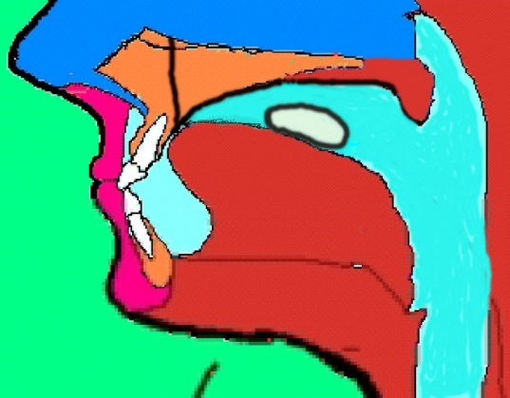
Fig. 1 The position of the tongue during correct swallowing

These receptors are the same that, in the foot, are involved in postural control.
The studies on trigeminal functions – amongst them those performed by Dr. De Cicco from the Pisa University – indicate a close relation between trigeminal stimulation and the release of neuromodulators by the CNS – which applies in particular to the functions of the “Locus coeruleus”.(9)
The functionality of this nucleus is of utmost significance for the brain’s overall viability, as it yields more than 70% of all circulating noradrenalin indispensable for the production of those neuro-mediators related to sleep and memory.
It is a frequently made clinical observation: many patients suffering from incorrect swallowing suffering from bruxism and when patients, suffering from bruxism, undergo deglutition rehabilitation therapies, the respective functional disorder will also be resolved within a period of approx. 3 months. Continued teeth grinding is most rare.
The observation that trigeminal palatal receptor stimulation,(that there is only when swallowing is correct)(18) – as achieved by the rehabilitation of the tongue functionality – results in clinical improvement, led us to the hypothesis that an alteration of the trigeminal function is accompanied by bruxism, and that bruxism itself is no parafunction but an actually positive phenomenon, having detrimental effects (it is an attempt to stimulate the trigeminus by releasing neuromediators. If patient is not able to stimulate palate receptors, simulates trigeminus of parodontal tissue by clenching and bruxing). (10)
Another observation can be done: bruxism is significantly present in children with nasal obstruction (and consequent tongue in low position to favour the breathing, but far from the palatal receptors). (11)
The study of the relation between sleep and memorizing information revealed a new aspect, which - according to our opinion - should be reflected.
Recent studies on sleep cycles relate paradoxical sleep (REM sleep) to memorizing information, which has been accumulated during the day.(12,13,14,15,16) ( This is supposed to be evidenced by the fact that children need a lot of sleep (they need to memorize large amounts of new information), while elderly persons sleep progressively less (they have already memorized the majority of information). Moreover, people who go blind in adulthood significantly reduce the number of hours they spend sleeping without suffering from any fatigue (vision-related experiences make up approx. 80% of the information to be memorized; people who lose their vision deploy their visual memory to a far less extent). It is a fact that Locus coeruleus is anatomically and physiologically linked to the limbic memory center, amygdale, and hippocampus.(9,17) It is also a fact that Locus coeruleus releases specific mediators, through the trigeminus stimulation (9,17). In physiological deglutition the tongue progressively pushes against the palate starting from the emergence of the nose-palatine nerve.
Problems of childbirth, lactation with artificial methods, spoiled habits, anatomical problems such as a shortened lingual frenulum that prevents the tongue from touching the palade, tend to decrease or cancel contact with the palate causing a decrease in trigeminal stimulation. If there is a decrease or lack of the nose-palatine nerve receptor stimulation, the need to produce neuromediators for memorizing processes might induce the stimulation of alternative trigeminal receptors and thus cause an activation of the Locus coeruleus. Activating the parodontal receptors – as generated by dental contact – answers the purpose intended; however, it comes at a price. While nose-palatine stimuli spread across fibers that feature “moderate conduction” and are thus present even after actual stimulation has taken place, parodontal stimuli deploy high-speed fibers, whose information needs only few msec to access the brain (10). As soon as the brain receives the information, the respective signal is replaced by the subsequent one in order to inform the CNS on the jaw position and the masseteric tonicity “in real-time”. In order to keep the trigeminus activated, the teeth thus require continuous contact - which results in muscular hypertension and dental/joint disorders.
These assumptions constitute the base for regarding efficient myofunctional retraining of tongue behavior and deglutition an etiological solution to bruxism.

Materials and Methods
We examined 80 patients (20-34 years old) suffering from deglutition disorders and consequential lack of stimulation of the nose-palatine nerve’s receptors. To diagnose a swallowing problem was used Fluorescine with Paine technique (18). The patients were randomized and clustered in two groups of each 40 persons.
The first group’s patients (Group A) underwent myofunctional therapy according to Garliner (modified by Ferrante) for 3 months (19,20). Patients clustered in the second group were further divided into two groups of each 20 people. Twenty individuals (Group B1) did not receive any treatment and were simply monitored for bruxism; the remaining 20 patients (Group B2) used “Bite Strips” to reduce parafunctional activities (21,22).
All patients were subjected to clinical examinations, applying fluorescein and the Paine-technique to evaluate their respective deglutition performance. At the beginning of the study and after expiration of three months, the masseteric tonicity was checked by deploying both, the Myometer developed by Garliner as well as surface-electromyography (an indirect method serving to assess the state of the muscular training, used in 10 subiects to confirm the measurements obtained with the Myometer Fig. 2, Fig.3). The patients were asked to complete a questionnaire regarding their individual perception of teeth grinding, muscular fatigue after waking up, and bruxism-related noise perceived by possible roommates.
Exclusion criteria: ankyloglossia or shortened lingual frenulum (based upon the inability of correcting the tongue behavior without surgical intervention) as well as diseases which preclude participation in rehabilitative treatments.
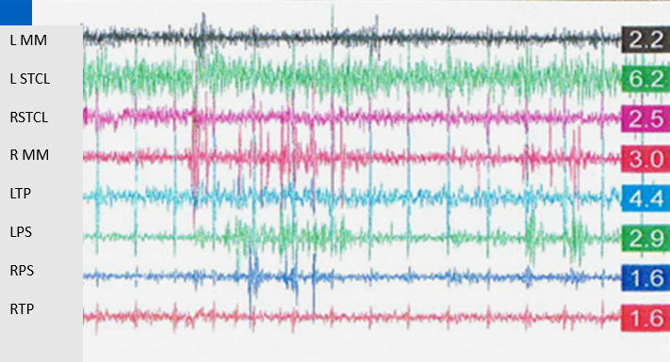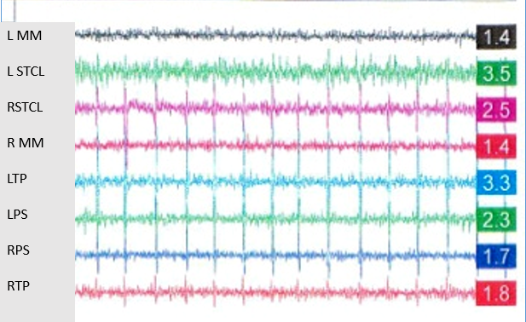
Fig. 2 time 0 Fig. 3 After 3 months of therapy
Results
Amongst those 40 patients receiving myofunctional therapy, 34 completely desisted from bruxism, and featured a decrease of muscular tonicity by more than 52% (as measured by myometer) as well as electromyographic values reduced by up to 54%. With 4 patients, a clinical improvement of bruxism and a slight improvement of respective values were found; two patients showed no improvement at all. (table 1,2 ) ( Group A)

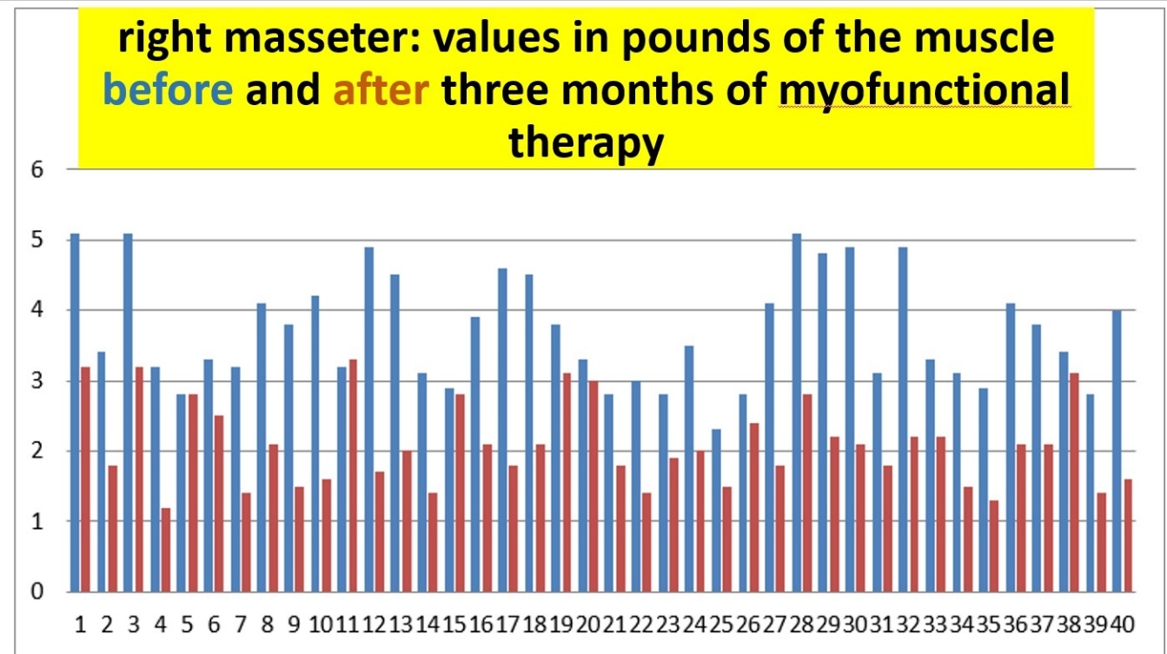
Table 1 Right Masseter

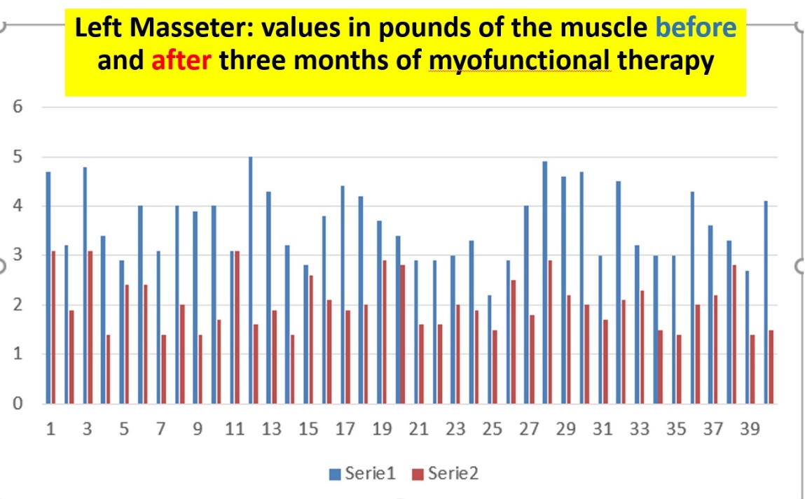
Table 2 Left Masseter

The values featured by the patients of Group B1 remained stable, with the initial muscles hypertension featuring minimal fluctuations only (table 3, 4). Amongst the 20 patients participating in Group B2 (table 5, 6), 13 showed no deviations from the initial conditions; with 4 of them, slight muscular tonicity improvement was found, in 3 cases, the tonicity deteriorated in combination with intensified clinical symptoms.
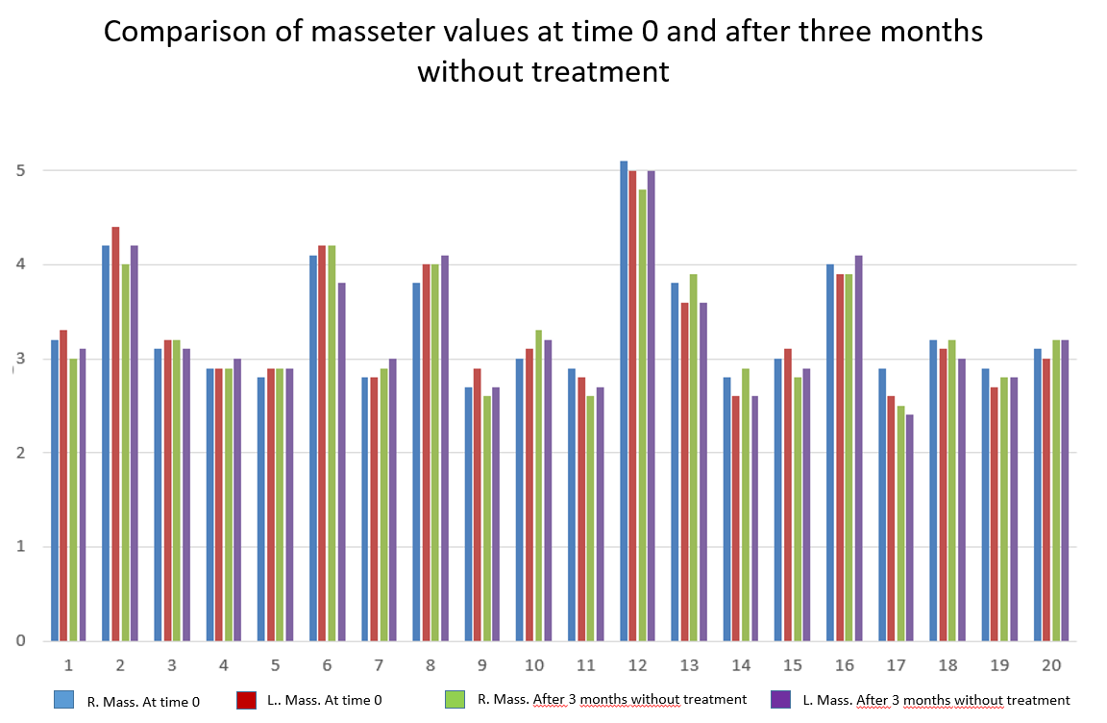
Table 3

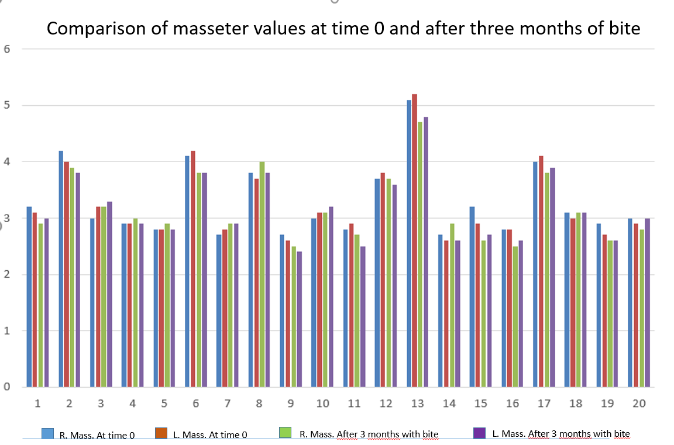
Table 5
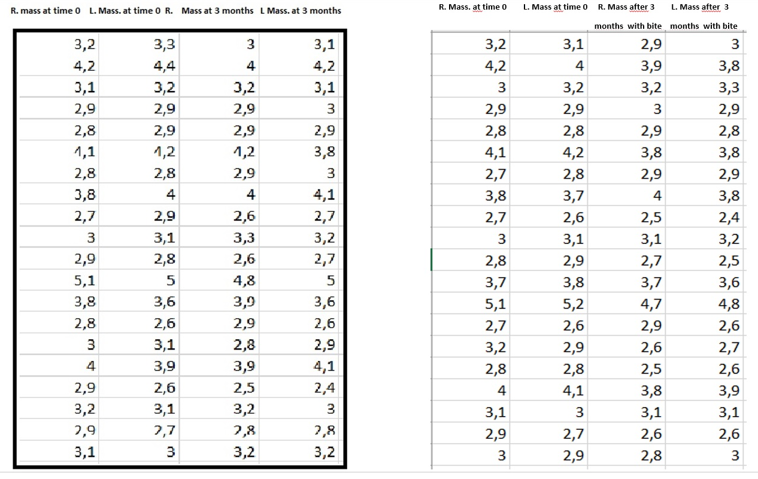
Table 4 Table 6
We have also done T Student for right Massetere (DX) but it is the same also for the others.

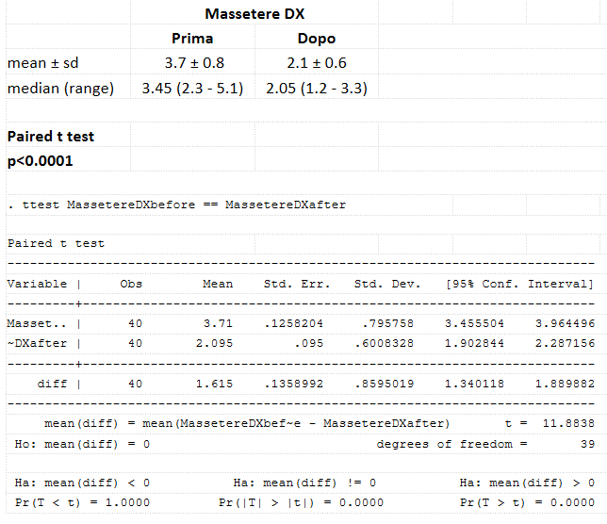

Conclusion
The results found with deglutition rehabilitation therapy - which are neurologically based upon appropriate stimulation of the second trigeminus branch, located in the nasopalatine nerve area – allow for concluding that suchlike stimulation will resolve bruxism by neurologically rehabilitating the respective function (probably based upon a restoration of the neurotransmitters release initiated by Locus coeruleus). However, complementary studies will have to facilitate respective biochemical analyses. An initial validation is provided by a master thesis, examining deviations in serotonin production related to palatal stimulation, which has been presented at the Department for Posturology at “La Sapienza” University in Rome (in print).

Bibliografia
1) Kato T, Thie NM, Huynh N, Miyawaki S, Lavigne GJ. Topical review: sleep bruxism and the role of peripheral sensory influences. J Orofac Pain. 2003 Summer;17(3):191-213.

2) Huynh N, Kato T, Rompré PH, Okura K, Saber M, Lanfranchi PA, Montplaisir JY, Lavigne GJ. Sleep bruxism is associated to micro-arousals and an increase in cardiac sympathetic activit y J Sleep Res. 2006 Sep;15(3):339-46.

3) Khoury S, Rouleau GA, Rompré PH, Mayer P, Montplaisir JY, Lavigne GJ, A significant increase in breathing amplitude precedes sleep bruxism.Chest. 2008 May 19.

4) Lavigne GJ, Huynh N, Kato T, Okura K, Adachi K, Yao D, Sessle B.: Genesis of sleep bruxism: motor and autonomic-cardiac interactions. Arch Oral Biol. 2007 Apr;52(4):381-4.
5) Cuccia A.M. : Eziologia del bruxismo notturno:una revisione della letteratura. RPM Vol. 99, N. 6, Giugno 2008; Pagg. 322-328

6) Sari S., Sonmez H.: The relationship between occlusal factors and bruxism in permanent and mixed dentition in Turkish children. J. Clin. Ped. Dent. 2001; 25: 191-4
7) Lavigne GJ, Rompré PH, Poirier G, Huard H, Kato T, Montplaisir JY : Rhythmic masticatory muscle activity during sleep in humans. J Dent Res. 2001 Feb;80(2):443-8
8) Halata Z., Baumann K.I.: “Sensory nerve endings in the hard palate and papilla incisiva of the rhesus monkey”; Anatomy and Embriology, 1999,vol.199, iss.5, pp 427-437,
9) Chiesa D., Ciaravolo P., Colasanto S., De Cicco V., Ferrante A.: “La Nuova Ortodonzia”, 2007, GLM Marrapese ed.,
10)De Cicco V.:”Il fuso Neuro-muscolare e S.N.C.”Ptero, 1, ,1999, gennaio, pp 79-84
11) Grechi T. H., Trawitzki L.V.V., de Felicio C. M.,Valera F.C.P., Alnselmo-Lima W. T.: “Bruxism in children with nasal obstruction” ,International Journal of Pediatric Otorhinolaryngology (2008) 72, 391—396
12)Diekelmann S, Born J.The memory function of sleep. Nat Rev Neurosci. 2010 Feb;11(2):114-26.
13)Jouvet M. : Sleep and serotonin: an unfinished story. Neuropsychopharmacology. 1999 Aug;21(2 Suppl):24S-27S.
14) Jouvet M. : Paradoxical sleep as a programming system. J Sleep Res. 1998;7 Suppl 1:1-5.
15) Paller KA, Voss JL Memory reactivation and consolidation during sleepLearn Mem. 2004 Nov-Dec;11(6):664-70

16) Wilhelm I, Diekelmann S, Born J.: Sleep in children improves memory performance on declarative but not procedural tasks. Learn Mem. 2008 Apr 25;15(5):373-7
17) Kandel E., Schwartz J., Jessel T.: Principi di Neuroscienze, 2007. Ed. Ambrosiana
18) Ferrante A., “Terapia miofunzionale, dalla deglutizione atipica ai problemi posturali”, Futura Publ. Society, 1997

19) Ferrante A. Manuale pratico di Terapia Miofunzionale, “2004, Marrapese ed. Roma
20) Garliner D.: Myofunctional Therapy; 1981, Philadelphia, W.B. Sauders Co.,

21) Attanasio R.: An overview of bruxism and its management . Dent. Clin. North Am. 1997;41: 229-41

22) Sheikholeslam A., Holmgren K., Riis C.: Therapeutic effects of plane occlusal splint on signs and symptoms of craniomandibular disorders in patients with nocturnal bruxism. J. Oral Rehabil. 1993; 20: 473-82

